**Translate speech-to-text by using the Azure AI Speech service**

The standard feature offered by the Speech service is the ability to take in an input audio stream in your specified source language, and have it translated and outputted as text in your specified target language.

<https://github.com/Azure-Samples/cognitive-services-speech-sdk/blob/master/samples/csharp/sharedcontent/console/translation_samples.cs#L472>

**Create a speech translation configuration**

To call the Speech service by using the Speech SDK, you need to create a [SpeechTranslationConfig](https://learn.microsoft.com/en-us/dotnet/api/microsoft.cognitiveservices.speech.speechtranslationconfig) instance. This class includes information about your subscription, like your key and associated region, endpoint, host, or authorization token.

**Change the source language**

One common task of speech translation is specifying the input (or source) language. The following example shows how you would change the input language to Italian. In your code, interact with the SpeechTranslationConfig instance by assigning it to the [SpeechRecognitionLanguage](https://learn.microsoft.com/en-us/dotnet/api/microsoft.cognitiveservices.speech.speechconfig.speechrecognitionlanguage) property:

**Add a translation language**

Another common task of speech translation is to specify target translation languages. At least one is required, but multiples are supported. The following code snippet sets both French and German as translation language targets:

With every call to [AddTargetLanguage](https://learn.microsoft.com/en-us/dotnet/api/microsoft.cognitiveservices.speech.speechtranslationconfig.addtargetlanguage), a new target translation language is specified. In other words, when speech is recognized from the source language, each target translation is available as part of the resulting translation operation.

**Initialize a translation recognizer**

After you created a [SpeechTranslationConfig](https://learn.microsoft.com/en-us/dotnet/api/microsoft.cognitiveservices.speech.speechtranslationconfig) instance, the next step is to initialize [TranslationRecognizer](https://learn.microsoft.com/en-us/dotnet/api/microsoft.cognitiveservices.speech.translation.translationrecognizer). When you initialize **TranslationRecognizer**, you need to pass it your **speechTranslationConfig** instance. The configuration object provides the credentials that the Speech service requires to validate your request.

If you're recognizing speech by using your device's default microphone, here's what the TranslationRecognizer instance should look like:

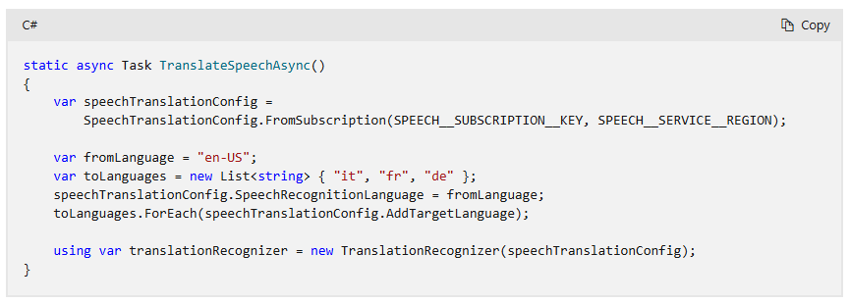

If you want to specify the audio input device, then you need to create an [AudioConfig](https://learn.microsoft.com/en-us/dotnet/api/microsoft.cognitiveservices.speech.audio.audioconfig) class instance and provide the **audioConfig** parameter when initializing **TranslationRecognizer**.

First, reference the AudioConfig object as follows:

If you want to provide an audio file instead of using a microphone, you still need to provide an audioConfig parameter. However, when you create an AudioConfig class instance, instead of calling FromDefaultMicrophoneInput, you call FromWavFileInput and pass the filename parameter:

**Translate speech**

To translate speech, the Speech SDK relies on a microphone or an audio file input. Speech recognition occurs before speech translation. After all objects are initialized, call the recognize-once function and get the result:

**Event based translation**

The TranslationRecognizer object exposes a Recognizing event. The event fires several times and provides a mechanism to retrieve the intermediate translation results.

